ANSIBLE → ORCHESTRATOR TRANSITION
Event Log Archive Architecture
Two workflows move archived Windows event logs off the estate and keep the archive share trimmed. This document shows where every piece lives, what talks to what, and which link is still done by hand.
System  Windows event log archives | Platform  VCF Operations Orchestrator 9 | Source of truth  GitLab · psscript
Script delivery  Manual → automated (planned) | Replaces  5 Ansible playbooks | Credentials at run time  None — stored on endpoints
How to read the diagrams
━━━ Run time
Flow while a workflow is running. Left to right.
━━━ Manual, today
A step a person performs. The only one left in the design.
┄┄┄ Planned
Not built yet. Replaces the manual step above it.
│ Second hop
Where the PowerShell host authenticates onward on its own behalf.
1 The whole path
Deployment runs down the page; everything at run time runs across it. The two axes are separate on purpose - getting code into Orchestrator is a build-time concern, not another hop in the data path.
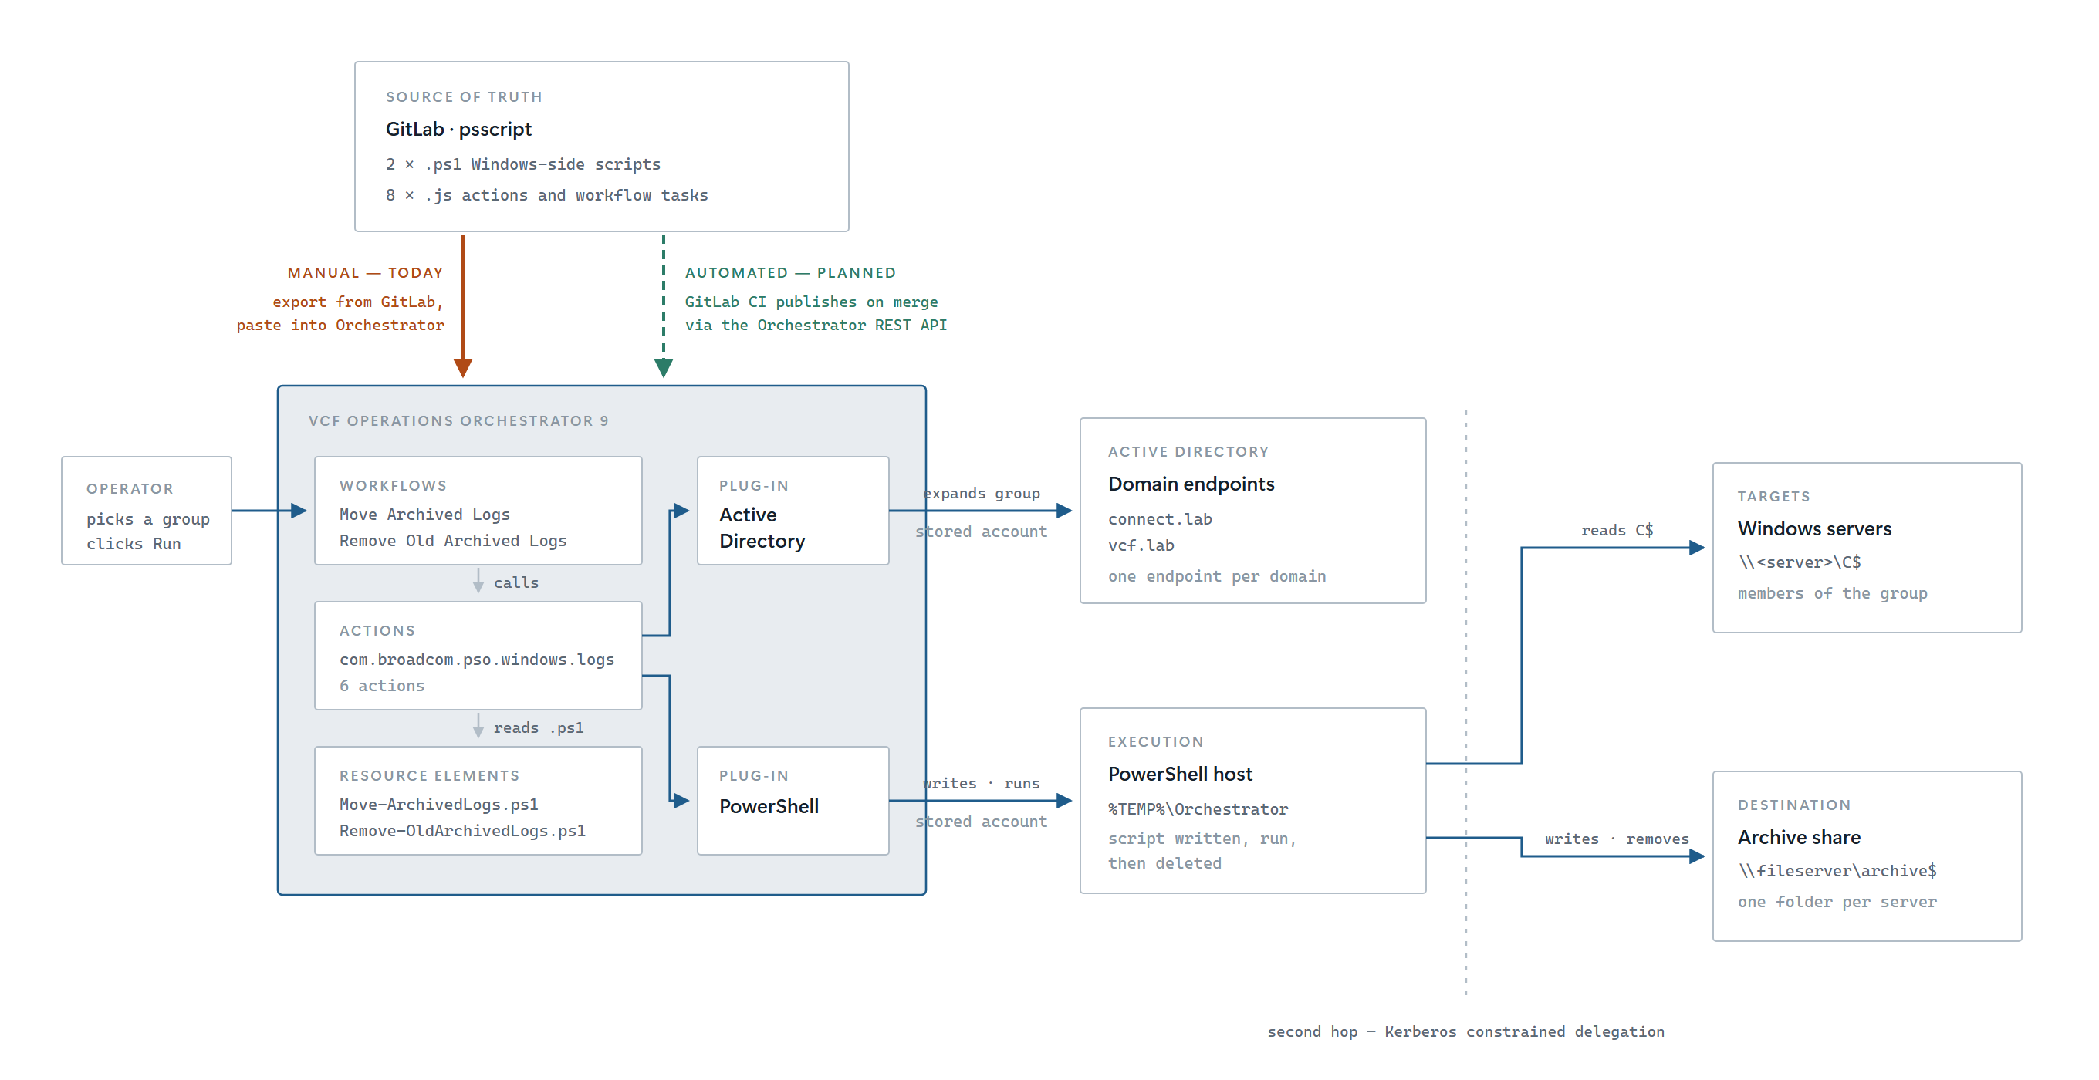
Figure 1. The only credentials in the picture are held on the two plug-in endpoints inside Orchestrator. Nothing is typed by an operator and nothing is carried in a workflow input.
2 Getting code into Orchestrator
The one link that changes. Today a person carries the code across; in the planned state a pipeline does, and the repository becomes authoritative rather than merely a copy.
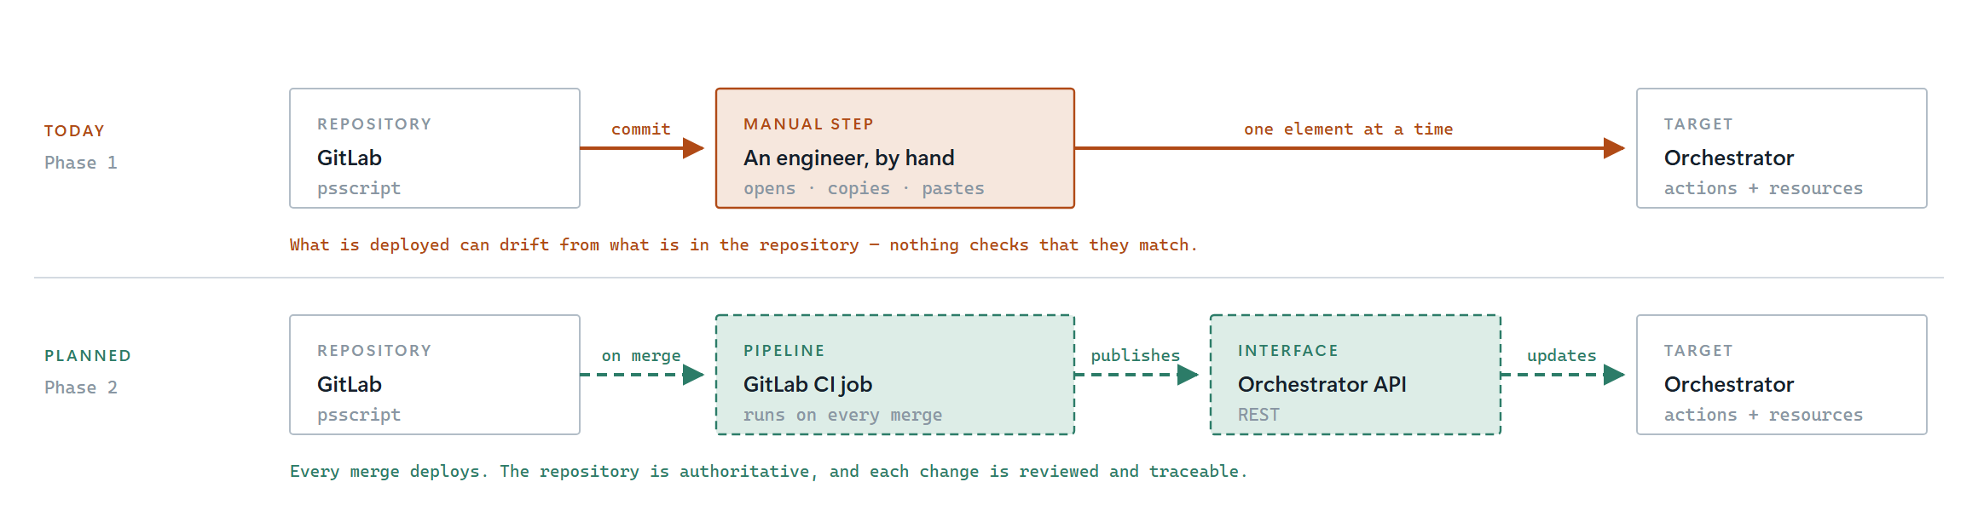
Figure 2. Both rows start and end in the same place. What differs is the middle: a person, or a pipeline and an API.
3 What the drawing is asserting
Where the credentials are  Nowhere on the wire. The Active Directory plug-in authenticates with the account stored against each domain endpoint, and the PowerShell plug-in with the account stored against the host. No workflow input accepts a username or a password, which retired the playbooks' WinRM_username and WinRM_password variables along with the hop that needed them. | Why the domain is never asked for  The operator picks a group from a tree, so the group object arrives already bound to its endpoint. For scheduled runs, the DC= components of the group's distinguishedName name the domain, and the endpoint follows from that. In both paths the domain is derived, never entered - so it cannot disagree with the group.
The second hop  Orchestrator connects to the PowerShell host; the host then reaches the servers and the share on its own behalf. That crossing needs Kerberos constrained delegation. Ansible never had this problem because it connected to each server directly - it is the one genuinely new piece of infrastructure in this design, so prove it before anything else. | The script's short life  A script is held in Orchestrator as a Resource Element, written to %TEMP%\Orchestrator on the host, run by path, then deleted. Nothing is pre-staged and nothing is left behind to drift out of step with the version Orchestrator holds.
Why the transfer is manual today  Phase 1 delivers ten files that are pasted into Orchestrator once. Automating the transfer means a pipeline that authenticates to the Orchestrator API, and it needs its own service account, its own secret handling, and a rollback story. That is a project in its own right, and it does not block the workflows from running. | What automation would buy  Today nothing compares what is deployed against what is committed, so the two can differ silently and a fix made in Orchestrator can be lost at the next paste. A pipeline makes the repository authoritative: every change is reviewed, versioned and traceable, and redeploying is a merge rather than an afternoon.
Move Windows Event Logs · Ansible → Orchestrator transition · Phase 1

